1. Bob’s retirement Savings will run out at the **age of 87** as per our analysis. We did the Break even analysis on his Year end assets after retirement and the value came 1 corresponding to age 87. The Year end assets went negative after that point.

Assumptions -:

* Bob is not using his extra income (post tax- column I ) after retirement .
* Bob is withdrawing the expense after retirement in start of the year so hi is getting return only on the leftover amount

1. Tornado Chart

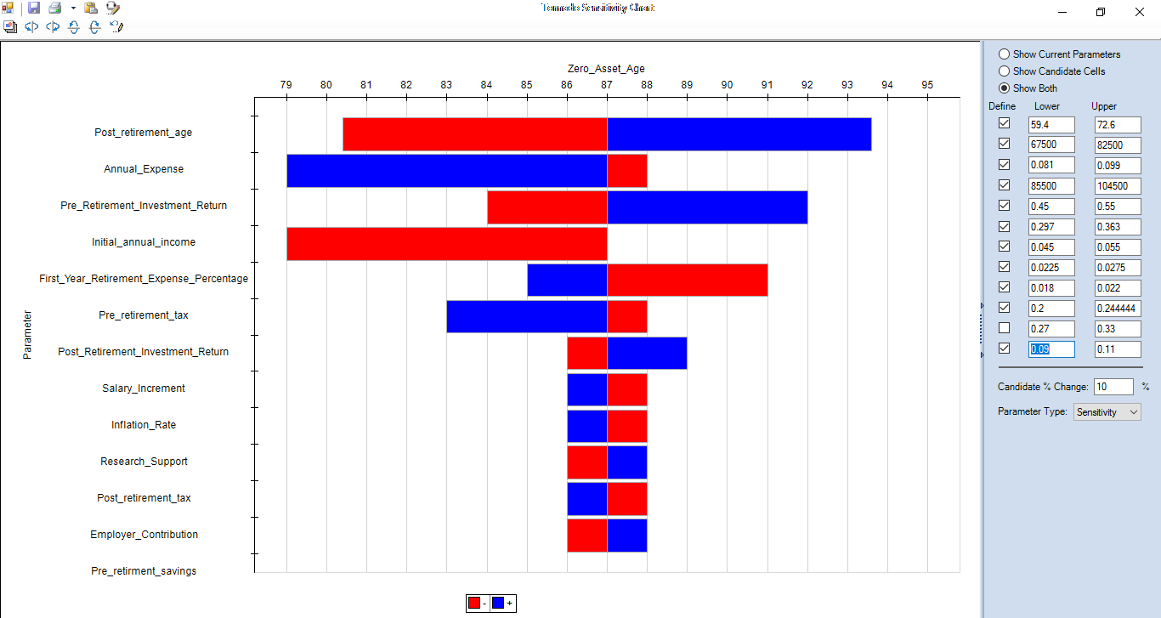

**Annual expense vs zero asset age:**

As can be seen from the graph these two variables are indirectly proportional.

When the expense decreases by 10%, the zero asset age increases to the age of 88.

When the expense increases by 10%, the zero asset age decreases to 79.

**Pre-retirement investment return vs zero asset age:**

As can be seen from the graph these two variables are directly proportional.

When the Pre-retirement investment return decreases by 10%, the zero asset age decreases to the age of 84.

When the Pre-retirement investment return increases by 10%, the zero asset age increases to 92.

**Initial Annual Income vs zero asset age:**

As can be seen from the graph these two variables are directly proportional.

When the Initial Annual Income decreases by 10%, the zero asset age decreases to the age of 79.

**First year retirement expense percentage vs zero asset age:**

As can be seen from the graph these two variables are indirectly proportional.

When the First year retirement expense percentage decreases by 10%, the zero asset age increases to the age of 85.

When the First year retirement expense percentage increases by 10%, the zero asset age decreases to 91.

**Pre-retirement tax vs zero asset age:**

As can be seen from the graph these two variables are indirectly proportional.

When the Pre-retirement tax decreases by 10%, the zero asset age increases to the age of 88.

When the Pre-retirement tax increases by 10%, the zero asset age decreases to 83.

**Post retirement investment return vs zero asset age:**

As can be seen from the graph these two variables are directly proportional.

When the Post retirement investment return decreases by 10%, the zero asset age decreases to the age of 86.

When the Post retirement investment return increases by 10%, the zero asset age increases to 89.

**Salary Increment vs zero asset age:**

As can be seen from the graph these two variables are indirectly proportional.

When the Salary Increment decreases by 10%, the zero asset age increases to the age of 88.

When the Salary Increment increases by 10%, the zero asset age decreases to 86.

**Inflation rate vs zero asset age:**

As can be seen from the graph these two variables are indirectly proportional.

When the inflation rate decreases by 10%, the zero asset age increases to the age of 88.

When the inflation rate increases by 10%, the zero asset age decreases to 86.

Similarly, research support money and employer contribution are directly proportional to zero asset age. Post-retirement tax is indirectly proportional to the zero asset age.

1. The ***minimum additional savings***(currently $7,500, all before tax)Bob needs to contribute such that Bob’s retirement assets do not run out before age 90 is **15900**. We obtained this value by Goal seek analysis.

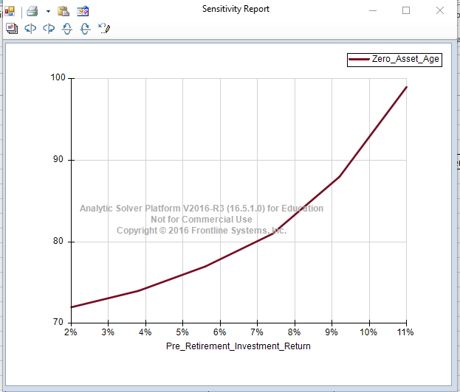

We can see from the graph that pre-retirement investment return and zero asset age are directly proportional. As pre retirement investment increases , zero asset age also increases.

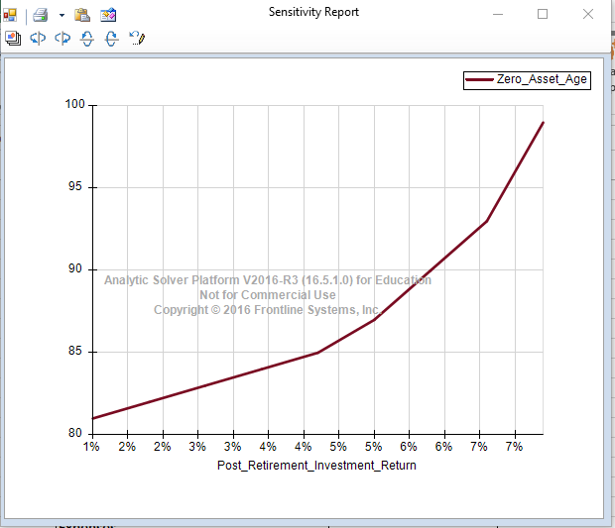

Post retirement investment return and zero asset age are directly proportional.As the post retiremrnt investment increases , zero asset age also increases.

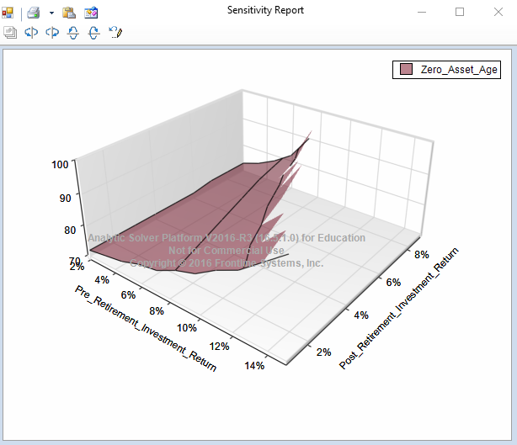

We can see from the graph that with respect to both the variables – pre retirement investment return and post retirement investment return, the value of age is also increasing.

1. **How does Bob’s *zero-asset age* vary with the age at which he retires? Display a chart assuming a retirement age between 60 and 70 years.**

**Answer :-**

|  |  |
| --- | --- |
| **Graph** | **Observation** |
|  | As can be seen from the graph Bob’s *zero-asset age* is directly proportional to the age at which he retires. |

**How does Bob’s *zero-asset age* vary with post-retirement tax rate? Vary the tax rate from 20% to 40% in 2% steps.**

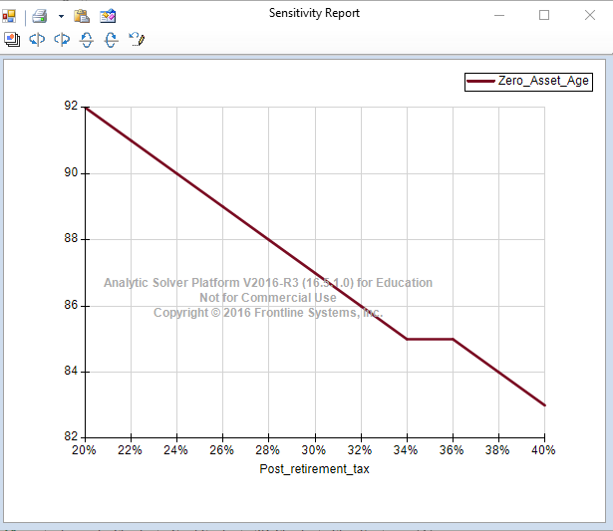

**Answer**: Bob’s *zero-asset age* is indirectly proportional with post-retirement tax rate.When the tax rate increases his money will run out early and zero asset age decreases.